INTRODUCTION TO DOCUMENTATION – MICROSOFT WORD (VERSION 2019)
  - Student can use this material as a template

Instructor: <Tên Giảng viên>
Student: <Họ và Tên> – Student ID: <Mã số>
Class: <Lớp> – Submission date: <dd/mm/yyyy>

Table of Contents
1. Table of Contents 2
2. Overview 3
3. Preparation 3
3.1. Vietnamese & Unicode 3
3.2. Structuring and Styling your document 3
3.3. Long-range Management 3
4. Layout & Standard Formatting 3
4.1. Pages & Margins 3
4.2. Header, Footer & Page Numbering 3
4.3. Characters & Paragraphs 3
5. When to use Bold / Italic / Underline? 4
6. List: Bulleted hay Numbered? 4
6.1. Numbered example for a procedure 4
6.2. Multilevel list & Heading numbering 4
7. Notes for Academic Document 4
8. Reviewing & Collaboration 4
9. Spelling & Language 5
10. Save, Publish & Recover 5
11. .doc vs .docx & Compatibility Mode 5
12. Using AI Tools in Document Writing 5
13. Interacting with Excel and PowerPoint for Word 6
13.1. Excel → Word 6
13.2. PowerPoint ↔ Word 6
14. Useful Keyboard Shortcuts 6
15. Other Notes 6
16. In-class Practices 6
17. Homework 7

Overview
Goal: author documents that are correct, clean, consistent, and easy to edit in Word 2019. Use Styles properly, apply heading numbering, generate an automatic Table of Contents, and master Excel/PowerPoint linking.

Preparation

Vietnamese & Unicode
• Use a Unicode input method (e.g., Unikey). Use Unicode fonts such as Times New Roman/Arial/Tahoma; avoid legacy encodings (TCVN3/VNI) to prevent rendering issues.

Structuring and Styling your document
• Apply Heading 1/2/3 for section titles; Normal for body text. Changing a Style updates all text using it. Generate the TOC from headings.
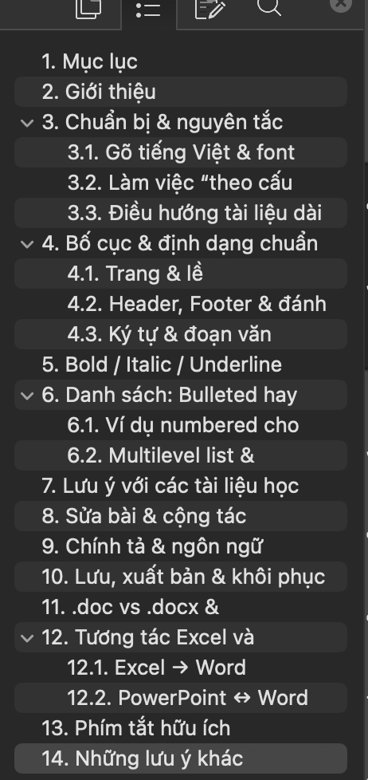
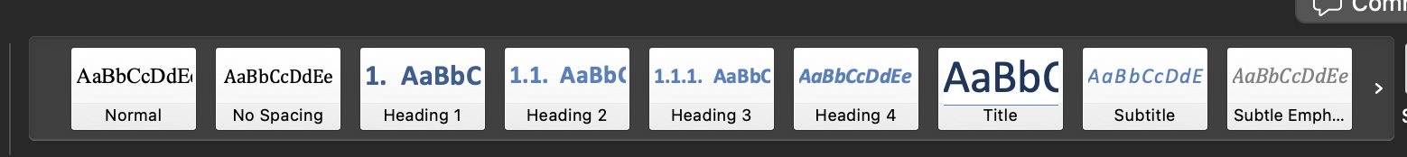

Long-range Management
• Open the Navigation Pane (View → Navigation Pane or Ctrl+F) to jump quickly by headings.

Layout & Standard Formatting

Pages & Margins
• Layout → Margins (A4 standard: 2.54 cm) – Layout → Size/Orientation.
• Use Section Break when needed.

Header, Footer & Page Numbering
• Insert → Header/Footer; Insert → Page Number (including Page X of Y).
• Turn on "Different First Page" to hide the page number on the cover.

Characters & Paragraphs
• Alignment, line spacing 1.15–1.5, paragraph spacing Before/After, and indentation per your institutional template.

When to use Bold / Italic / Underline?
• Bold: use sparingly for key terms; also for UI button/command names when instructing users.
• Italic: for light emphasis, terms, captions, or placeholders (e.g., <student-name>).
• Underline: avoid for emphasis; reserve for hyperlinks to prevent confusion.

List: Bulleted hay Numbered?
• Bulleted (•): unordered items.
• Numbered (1., 2., 3.): ordered steps or procedures.

Numbered example for a procedure
- Open the sample .docx document.
- Add a new section using Heading 2.
- Update the Table of Contents via Update Field.

Multilevel list & Heading numbering
• Attach numbering 1, 1.1, 1.1.1 to Heading 1/2/3 for stable, consistent structure. Use built-in Multilevel List linked to heading styles.

Notes for Academic Document
Main tips that you better know, but you should continue exploring in practice:
1) Apply Styles to headings and body text.
2) Build an automatic TOC: References → Table of Contents → Automatic.
3) Footnotes & References: References → Insert Footnote / Insert Citation & Bibliography (as required).
4) Navigate with the Navigation Pane; drag-and-drop to reorder sections.

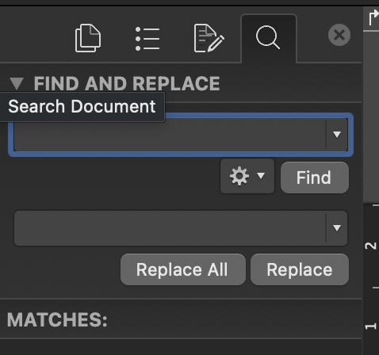
Reviewing & Collaboration
• Find/Replace: Ctrl+H; Ctrl+F to open the Navigation Pane.

• Track Changes: Review → Track Changes; Accept/Reject.
• Comment: Review → New Comment.

Spelling & Language
• F7 for spelling/grammar; Review → Spelling & Grammar.
• Review → Language → Set Proofing Language to choose the language for proofreading.

Save, Publish & Recover
• Save as .docx; share as PDF via File → Export/Save As → PDF. Frequently save with Ctrl+S to avoid losing edits.
• Recover unsaved work: File → Info → Manage Document → Recover Unsaved Documents.

.doc vs .docx & Compatibility Mode
• .doc: legacy binary format (Word 97–2003). Opening a .doc may trigger Compatibility Mode.
• .docx: Office Open XML (ZIP + XML), smaller, safer, supports modern features (Word 2007+). Use File → Info → Convert (or Save As) to upgrade the document into .docx.

Using AI Tools in Document Writing
With today’s AI tools, turning ideas into polished text fast is way easier—students don’t have to build every document from scratch anymore. For example, ChatGPT can generate content directly as a .docx file, without relying on third-party converters.
You can also check the ChatGPT conversation that was used to draft an early version of this guide at: https://chatgpt.com/share/68cf9401-5140-8002-bf8e-1875f7c77b55
NOTE THAT: AI-generated output should be a starting point for you to refine with your own knowledge and skills—not something you submit verbatim. Be sure to follow the detailed policies from both your Lecturer and your Lab instructors about using these tools in this course and across the program.
A few tips to use AI tools effectively:
• For chat-style tools like ChatGPT, Perplexity, and Gemini: first prompt for a clean, plain-text answer. Then, if you need it, ask the tool to convert that result into Microsoft Word formats like .docx or .doc. (On the web, Gemini can also export straight to Google Docs.)
• For one-shot generators like Gemma or Word Copilot: provide both the content prompt and the target format so the tool can produce the final document directly.
• To avoid made-up details (“hallucinations”), give the tool all the context it needs: the audience, your role (and ask it to adopt that role), the tone/style you want, plus any facts it must stick to.

Interacting with Excel and PowerPoint for Word

Excel → Word
• Use Home → Paste → Paste Special → Paste Link so tables/charts auto-update from the Excel source.
• Insert → Object → Create from File (Link to file) to link; clear it to embed a static copy.

PowerPoint ↔ Word
• PowerPoint: File → Export → Create Handouts (send slides + notes to Word).
• Alternatively, paste slides as images (stable layout) or use Paste Link to keep them updated.

Useful Keyboard Shortcuts
• Ctrl+B / Ctrl+I / Ctrl+U: bold / italic / underline
• Ctrl+H / Ctrl+F: Find & Replace / Navigate
• Ctrl+Z / Ctrl+Y: Undo / Redo

Other Notes
• Use Styles for all headings; don’t type numbers manually.
• Line spacing 1.15–1.5; clear paragraph spacing; Unicode fonts.
• Prefer Italic for light emphasis; use Bold sparingly; Underline for hyperlinks.
• Automatic TOC; Different First Page for cover; Page X of Y.
• Export to PDF for sharing.

In-class Practices
Open the PDF files provided in the attached 'Baitap' folder. Read each file’s content and layout carefully, then create a Word document that mirrors it exactly. Save each document as .docx with the same name as the source PDF, place them in a single folder with the required structure, then zip it as <StudentID>.zip to upload to Moodle.
AI tools are NOT allowed for this in-class practice.
<MSSV>
|--- 003.docx
|--- 005.docx
|--- 202.docx

Homework
Using the same PDFs and requirements as the in-class practice, convert them to .docx again—this time you must use AI tools and compare the AI-assisted results with your manual versions. In addition to the three documents, submit a short report describing how you used the AI tools and your comparison. If possible, include your prompt (for one-shot tools) or a shared link to the full chat (for chatbot tools).
<MSSV>
|--- 003.docx
|--- 005.docx
|--- 202.docx
|--- Report.docx

Note: You may use this guide’s formatting as a template for your report (Report.docx) when submitting.

